STORY: OVERVIEW PLAYERS OF TEAM

As a user

I'm able to get an overview of the players of a team So that I can see who are the players of that team

WIREFRAME

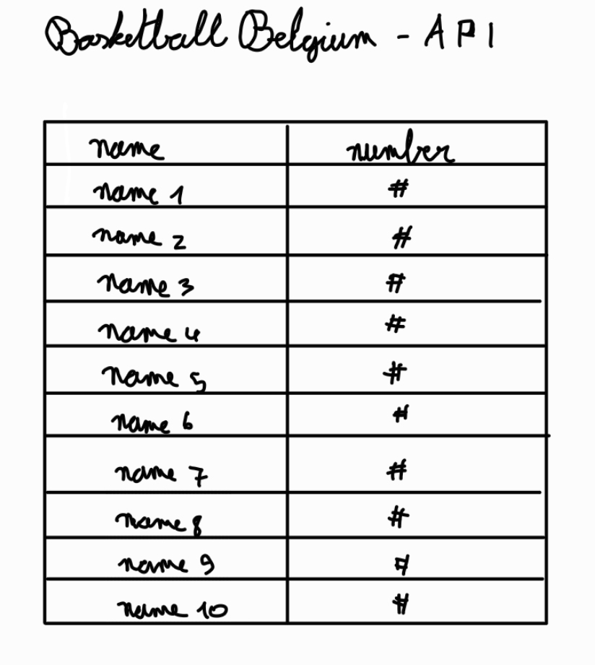

ACCEPTANCE CRITERIA

-The name of the team is displayed.

-A list of all the players of the team is displayed.

STORY: OVERVIEW TEAMS IN COMPETITIONS

As a user

I'm able to get an overview of all the teams in a competition So that I can see which teams are in that competition

WIREFRAME

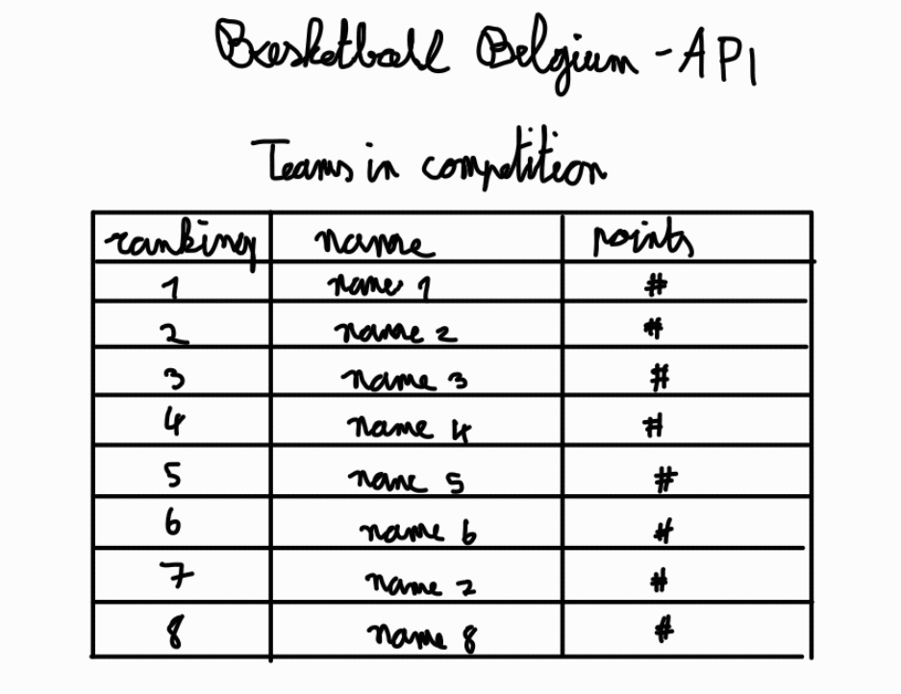

ACCEPTANCE CRITERIA

-The name of the competition is displayed.

-A list of all the teams in that competition are displayed and they are ranked according to their score.

-When clicked on a team, the user gets redirected to a page where they can view the players of that team.

STORY: OVERVIEW COMPETITIONS

As a user

I'm able to get a list of all the Belgian basketball competitions

So that I can see which Belgian basketball competitions there are

WIREFRAME

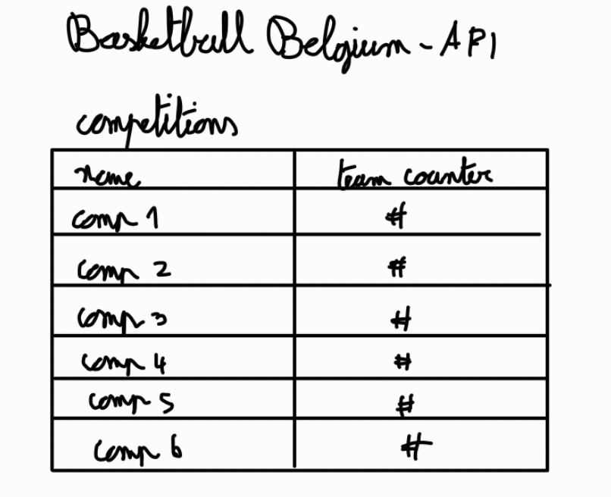

ACCEPTANCE CRITERIA

-A list of all the Belgian basketball competitions with the amount of teams within them are displayed.

-When there are no competitions, display "Currently no Belgian basketball competitions".

-When a competition gets clicked on, the teams in that competition are shown.

STORY: OVERVIEW COACHES OF TEAM

As a user

I'm able to get an overview of the coaches of a team So that I can see who are the coaches of that team

WIREFRAME

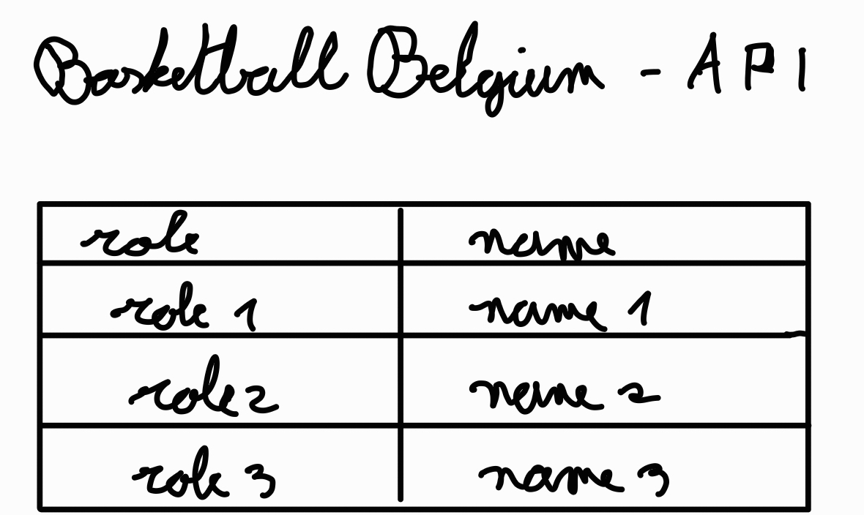

ACCEPTANCE CRITERIA

-The name of the team is displayed.

-A list of all the coaches of the team is displayed.